Cancer Care Ontario (CCO) ISAAC Application

HL7 Report User Guide
Version 1.0
Last Updated: May 2016

Table of Contents
This package is intended to be available to Integration support personnel at facilities that have implemented the ISAAC application with the optional HL7 integration features. This guide provides detailed information on the CCO ISAAC web application’s HL7 Integration Report with respect to the features and functionality offered. Included is an overview of the following:
Introduction 2
Overview 2
Accessing the Report 2
Report Filtering 3
Overview 3
Start and End Date 3
Message Type and Direction 3
Survey 4
Patient MRN and Health Card Number 4
Message ID, Site, and Process Code 4
Report Columns and Output 5
Report Columns 5
Report Output 5
List of Message Process Code Statuses 6
P000x = HL7 Process Codes 6
SPOx = Site Patient Operation Status Codes 7
AOSx = Assessment Operation Status Codes 7
POSx = Patient Operation Status Codes 8
ADT Status Codes 9
Appendix A: Version History 10
Document History 10
Appendix B: List of Figures 10

Introduction

Overview
The ISAAC application includes HL7 integration features to automate transmission of patient enrollment information automatically into the ISAAC system as well as survey data transmission between ISAAC and hospitals in both directions. As these features are designed to work automatically, there is no human presence to guide and validate the data under normal circumstances. However, there should be ways to monitor the process to ensure it runs smoothly and to troubleshoot when errors occur. The ISAAC operations team does monitor interfaces for errors and can assist with troubleshooting as requested. However, for the sites that would like to troubleshoot independently or have a view themselves while troubleshooting, the ISAAC application now supports this process with the HL7 integration Report which this document outlines how to use effectively.

Accessing the Report
The feature is available in the form of a report for users that have access to the Reports tab. From the tab, the report is located under the heading Integration Reports with the title Real-Time HL7 Report. The View button will open the report in a new tab of your internet browser.
Figure 1: The Report Tab
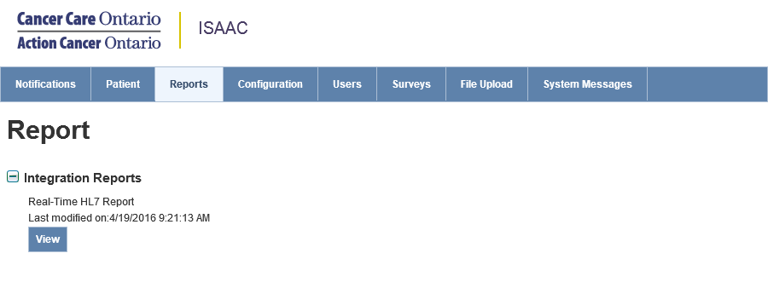

Report Filtering

Overview
There are 9 filters that can be used to tailor the results of the report in ways that are useful for each situation.
- Message Start Date
- Message End Date
- Message Type Direction
- Survey
- MRN
- Health Card Number
- Message ID
- Site
- Process Code
The filters will be applied once you have clicked the View Report button and the report will generate.

Figure 2: The Report Filter Fields
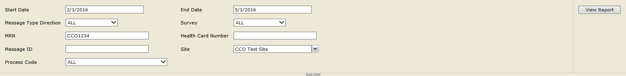

Start and End Date
The Start Date and End Date fields use the date the HL7 message was processed to filter all messages for a user-defined date range. Default times are populated to display messages processed in the 2-hours leading up to when the report was loaded. When using this feature, be weary of larger date ranges as they may time out as the report attempts to retrieve too much information. These are required parameters and cannot be blank.

Message Type and Direction
ISAAC’s current functionality allows patient assessment data to pass between ISAAC and hospital systems through an ORU (Observation Result) interface. When viewing interface messages for this survey information, you can filter the report to display only messages that are ORU Inbound to ISAAC from hospitals or ORU Outbound messages for survey information that are created from ISAAC and transmitted to hospitals.
ISAAC allows patient enrollment to be automated with an ADT (Admission, Discharge, and Transfer) interface. These are messages inbound into ISAAC from connected hospitals with information to enroll new patients or update existing patients. The two cases are defined as separate message types with individual codes: A28 Inbound for messages carrying new patient data that are not yet enrolled in ISAAC and A31 Inbound which are messages carrying patient update information for patients that have already been enrolled in ISAAC.
This is a required parameter. If you do not wish to filter your report by these options, you can use the default ALL value.

Survey
The ISAAC ORU interface is supported for existing ISAAC surveys that are not a part of pilot or research projects. If you would like to filter the report by specific survey title, the Survey filter allows you to select from the support surveys: ESAS-r, PRFS, ECOG, and PPS. This filter is an optional parameter.

Patient MRN and Health Card Number
If you would like to find messages for a specific patient the MRN and/or Health Card Number fields can be entered and the report will filter to only HL7 messages that have been transmitted for the matching patient. This includes ADT enrollment and updates as well as ORU survey transmission between CCO and hospitals. Both filters are optional parameters.

Message ID, Site, and Process Code
The last 3 filters are based around managing the interface messages. If you are a site that routes multiple hospitals though your own interface engine, you can filter messages by one or all of those facilities with the Site filter.
Each message is assigned a MessageID either by ISAAC if the message is outbound or by sites’ interfaces if the message is inbound into ISAAC. If you are working with interface managing tools, the MessageID filter will be a unique identifier if you wish to trace the path of the message. If the message was resent, and has the same MessageID, ISAAC should accept the message and the report show all instances.
The Process Code filter allows you to filter messages that have the same process status, whether that is a specific error or for messages that are successful. This aids in grouping messages with the same errors to resolve data quality bugs or monitoring or errors. Process code definitions are outlined later in this guide in the List of Message Process Code Statuses chapter.

Report Columns and Output

Report Columns
Figure 3: Table of Report Columns
# | Column Name | Column Description
1 | Message Date | The datetime that a message was processed by the ISAAC application
2 | Message Type | Message Type recorded in MSH-9 field of the HL7 message: ADT^A28, ADT^A28, or ORU^R01
3 | Survey Name | For ORU messages the Survey Name is recorded in the OBR-4 field and will be one of the supported ISAAC surveys. If the message is an ADT message, this field will be blank
4 | Message Direction | The direction of the message relative to ISAAC:  Inbound - The transmitted direction will have been Hospital ISAAC.  Outbound - The transmitted direction will have been ISAAC Hospital.
5 | Master Number | The 4-digit MOLTC assigned master number of the facility ISAAC has transmitted the message between. This is taken from the MSH-4 field for inbound messages and the MSH-6.1 field for outbound messages.
6 | Message ID | Unique identifier for the HL7 message recorded in MSH-10.
7 | Person Name | The name of the patient recorded in PID-5.1 and PID-5.2
8 | DOB | The birthdate of the patient recorded in in PID-7
9 | HCN | The Health Card Number recorded in PID-3.1 where PID3.5 is HC
10 | MRN | The Medical Record Number recorded in PID-3.1 where PID3.5 is PI
11 | Process Status | The real-time state of the message recorded by the ISAAC application. This is based on the BizTalk interface Process Codes. If the status is one of the different error statuses, the report will provide the message exception details in the following row of the report.

Report Output
Figure 4: HL7 Report Output
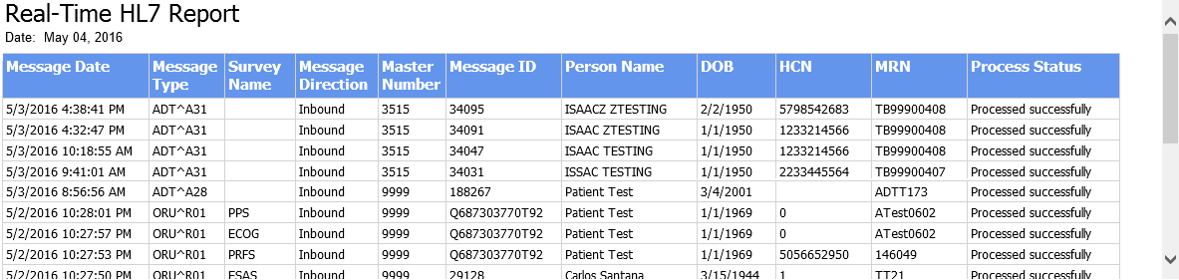

List of Message Process Code Statuses
The following chapter contains a list of error status codes that ISAAC will generate. When an error occurs, a pair of rows will be displayed in the HL7 report. The first row will populate the columns of the report and detail the message. The second row will provide the exception details:
Figure 5: HL7 Report Error Row Pair

P000x = HL7 Process Codes
The following is a table of HL7 Process Codes generated by the CCO BizTalk Interface:
Figure 6: Table of HL7 Process Codes
Code | Process Status | Description
P0001 | Processed Successfully | Message processed successfully without error as expected.
P0002 | Message In Process | Message has been received and is being processed by the ISAAC system or is pending response for hospital system.
P0003 | Consuming External Service | Sent the survey to hospital and is waiting for ACK/NACK (for outgoing messages)  BizTalk has processed the message and sent to the ISAAC application to process and is awaiting response.  Once the response received the process code has to be changed to a different one: success/error. However, some unhandled errors may leave messages in this state and will fail to update.
P0004 | Message Processing Exception | Various errors may cause processing exceptions at the BizTalk interface level before the ISAAC application is able to process a message. Common examples are the following:  - Formatting: unexpected values or missing required fields or value not matched in tables  - Authentication GUID: Site Authentication GUID and Site Number mismatch  - Connection Issues: Refused connection or message time outs
The respective examples for the three errors above are the following:
Message Exception: General Isaac Exception.HL7 receive message invalid/unknown format; PID.8(1) - Table value not found.; DG1.1(1) - Required field is missing.;
Message Exception: There was a failure executing the receive pipeline: "ISAAC.Interface.BizTalk.Pipelines.ADTFixedItineraryReceive Passthrough, ISAAC.Interface.BizTalk.Pipelines, Reason: Authentication failed for site 9999 (expected: 78F731A186B262726EA17B5, received: 18F731A186B262726E817B5)
Message Exception: No connection could be made because the target machine actively refused it 18.241.140.98:9123

SPOx = Site Patient Operation Status Codes
Site Patient Operation status codes are generated by the ISAAC application after completing initial processing by the BizTalk interface. The following table is a list of errors that can occur during the patient registration in ISAAC:
Figure 7: Table of ISAAC Site Patient Operation Status Codes
Code | Process Status
SPO2 | Site Not Found
SPO3 | Site Too Many Found
SPO4 | Patient Not Found
SPO5 | Patient Too Many Found
SPO6 | Patient Chart Number Missing
SPO7 | Patient Enrolment Failed – (one of the values below)  - Required Health Card Number - Required First Name  - Invalid Health Card Number - Invalid First Name  - Invalid Health Card Version - Required Gender  - Required Chart Number - Invalid Gender  - Invalid Chart Number - Required Birth Date  - Char Number Exists - Invalid Birth Date  - Required Surname - Concurrency Error  - Invalid Surname - Database Exception
SPO8 | Patient Already Registered

AOSx = Assessment Operation Status Codes
Assessment Operation status codes are generated by the ISAAC application after completing initial processing by the BizTalk interface. The following table is a list of errors that can occur during the survey (ESAS, PPS, etc.) assessment creation in ISAAC:
Figure 8: Table of ISAAC Assessment Operation Status Codes
Code | Process Status
AOS2 | Concurrency Error
AOS3 | Updated ESAS But Not Patient
AOS4 | Save Failure Invalid Data
AOS5 | Database Exception
AOS6 | Save Failure PPS Data Collision
AOS7 | Save Failure ESAS Data Collision
AOS8 | Invalid Assessment Date
AOS9 | Invalid ESAS Assessment Score
AOS10 | Invalid PPS Assessment Score
AOS11 | Required Assessment Date
AOS12 | Invalid ESAS Completed By
AOS13 | Invalid ECOG Assessment Grade
AOS14 | Save Failure ECOG Data Collision
AOS15 | Clinic Other Already Exists
AOS16 | Invalid Assessment Location
AOS17 | Invalid PRFS Assessment Rating
AOS18 | Invalid Assessment Date Range

POSx = Patient Operation Status Codes
The following is a table of Patient Operation Status codes generated by the ISAAC application after completing initial processing by the BizTalk interface:
Figure 9: Table of ISAAC Patient Operation Status Codes
Code | Process Status
POS2 | Required Health Card Number
POS3 | Invalid Health Card Number
POS4 | Invalid Health Card Version
POS5 | Required Chart Number
POS6 | Invalid Chart Number
POS7 | Chart Number Exists
POS8 | Required Surname
POS9 | Invalid Surname
POS10 | Required First Name
POS11 | Invalid First Name
POS12 | Required Gender
POS13 | Invalid Gender
POS14 | Required Birth Date
POS15 | Invalid Birth Date
POS16 | Invalid Death Date
POS17 | Invalid Postal Code
POS18 | Required Nursing Agency
POS19 | Invalid Nursing Agency
POS20 | Required Enrollment Date
POS21 | Invalid Enrollment Date
POS22 | Required Patient Type
POS23 | Invalid Patient Type
POS24 | Required Patient Disposition
POS25 | Invalid Patient Disposition
POS28 | Concurrency Error
POS29 | Database Exception
POS30 | Required Password
POS31 | Required Year Of Birth
POS32 | Invalid Birth Date Range

ADT Status Codes
The following is a table of ADT Specific status codes generated by the ISAAC application after completing initial processing by the BizTalk interface:
Figure 10: Table of ISAAC ADT Error Codes
Code | Process Status
REQF | ADT: Missing data for ADT processing
INVDOB | ADT: Invalid DOB format
RNGDOB | ADT: Invalid DOB range
INVDGDT | ADT: Invalid Diagnosis Date Time format
RNGDGDT | ADT: Invalid Diagnosis Date Time range
SCTNFD | ADT: Site Code Type Not Found
INVHCN | ADT: Invalid HCN
SNFD | ADT: Site Not Found
HCNU | ADT: HCN Is Not Unique
PSTS | ADT: Patient Existence Status Error
PCRT | ADT: Patient Create Error
PUPT1 | ADT: Patient Update (case #1) Error
PUPT2 | ADT: Patient Update (case #2) Error
PUPT3 | ADT: Patient Update (case #3) Error
PDUP2 | ADT: Patient exists (case #2), but MRN is duplicated
PNT3 | ADT: Patient exists (case #2), but not trusted
ADT1 | ADT: Patient exists (case #3), but not trusted
ADT2 | ADT: ADT31 received before patient create by ADT28

Appendix A: Version History

Document History
Revision | Type | Revision Date | Revised By | Revision Details
0.1 | Draft | May 4, 2016 | Daniel Blekkenhorst | Initial Version
1.0 | Final | May 4, 2016 | Daniel Blekkenhorst

Appendix B: List of Figures
Below is the list of each screenshot contained in the document. For reference, you can use the page number to find the figure or if you are using an electronic version of the guide, you can link directly from the line item below.
Figure 1: The Report Tab 2
Figure 2: The Report Filter Fields 3
Figure 3: Table of Report Columns 5
Figure 4: HL7 Report Output 5
Figure 5: HL7 Report Error Row Pair 6
Figure 6: Table of HL7 Process Codes 6
Figure 7: Table of ISAAC Site Patient Operation Status Codes 7
Figure 8: Table of ISAAC Assessment Operation Status Codes 7
Figure 9: Table of ISAAC Patient Operation Status Codes 8
Figure 10: Table of ISAAC ADT Error Codes 9

